Design Specification & UI Mockups • v1.0 • August 2026

Founder Signal — Design Specification & UI Mockups
Visual direction: premium research dashboard + startup opportunity radar. Data-rich, credible and calm rather than a generic AI idea generator.

1. Design Principles
- Evidence before hype.
- Dense but scannable.
- Visual trust through source diversity and momentum.
- Progressive disclosure.
- Neutral visual language; avoid fake precision.
- AI is the interpreter, not the source of truth.

2. Visual System
Element | Specification
Background | #F7F8FA
Cards | White, 16–20px radius, subtle border
Text | #111827
Muted | #6B7280
Positive | #16A34A
Attention | #F59E0B
Negative | #DC2626
Accent | #2563EB
Typography | Inter/Aptos-style sans
Charts | Minimal gridlines, clear labels, tooltips
Spacing | 8px base grid

3. Home Dashboard
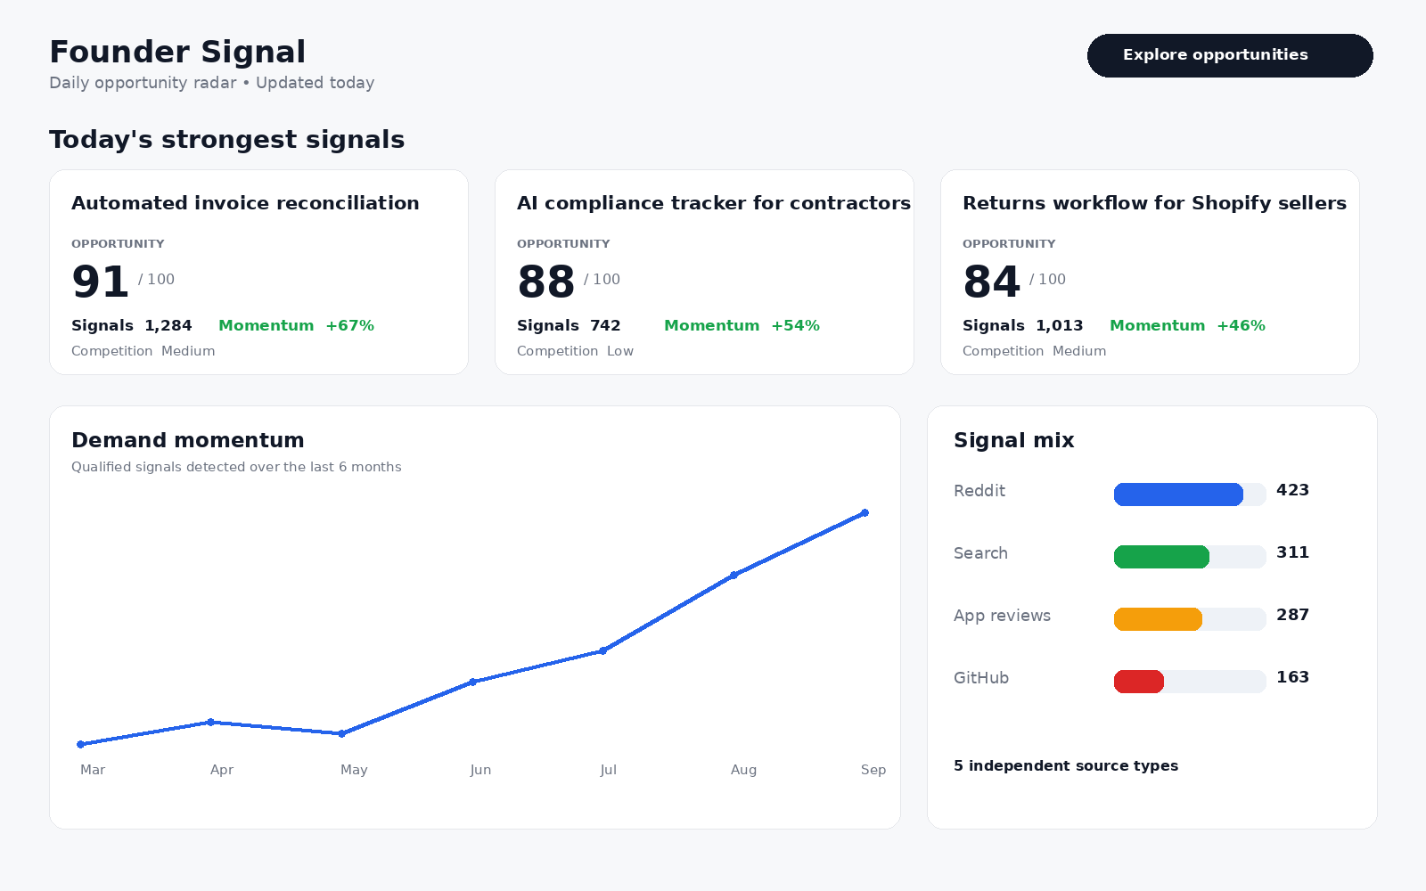
Daily return surface: strongest opportunities, demand momentum and signal mix.

4. Opportunity Detail
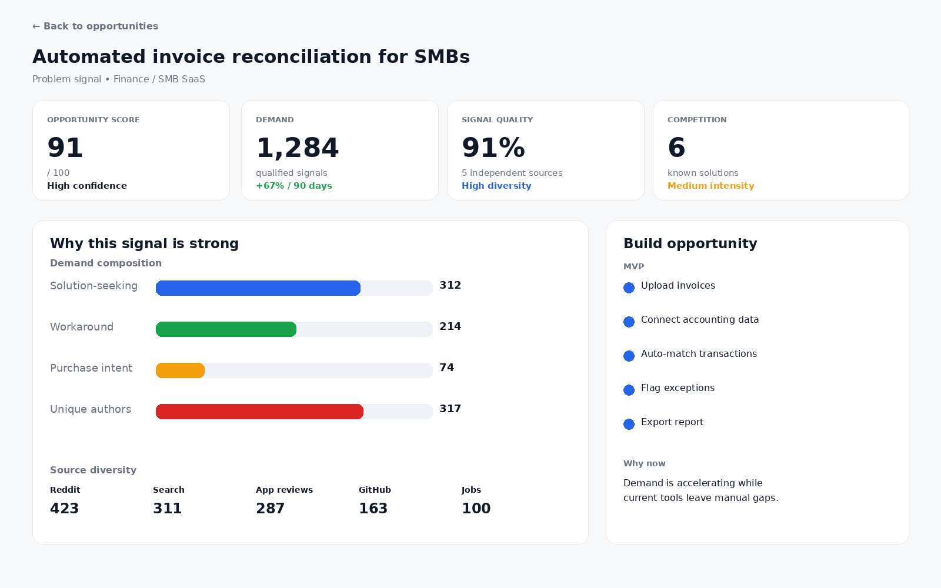
Trust-building screen: score, demand, signal quality, competition, intent mix, source diversity and MVP blueprint.

5. Signal Explorer
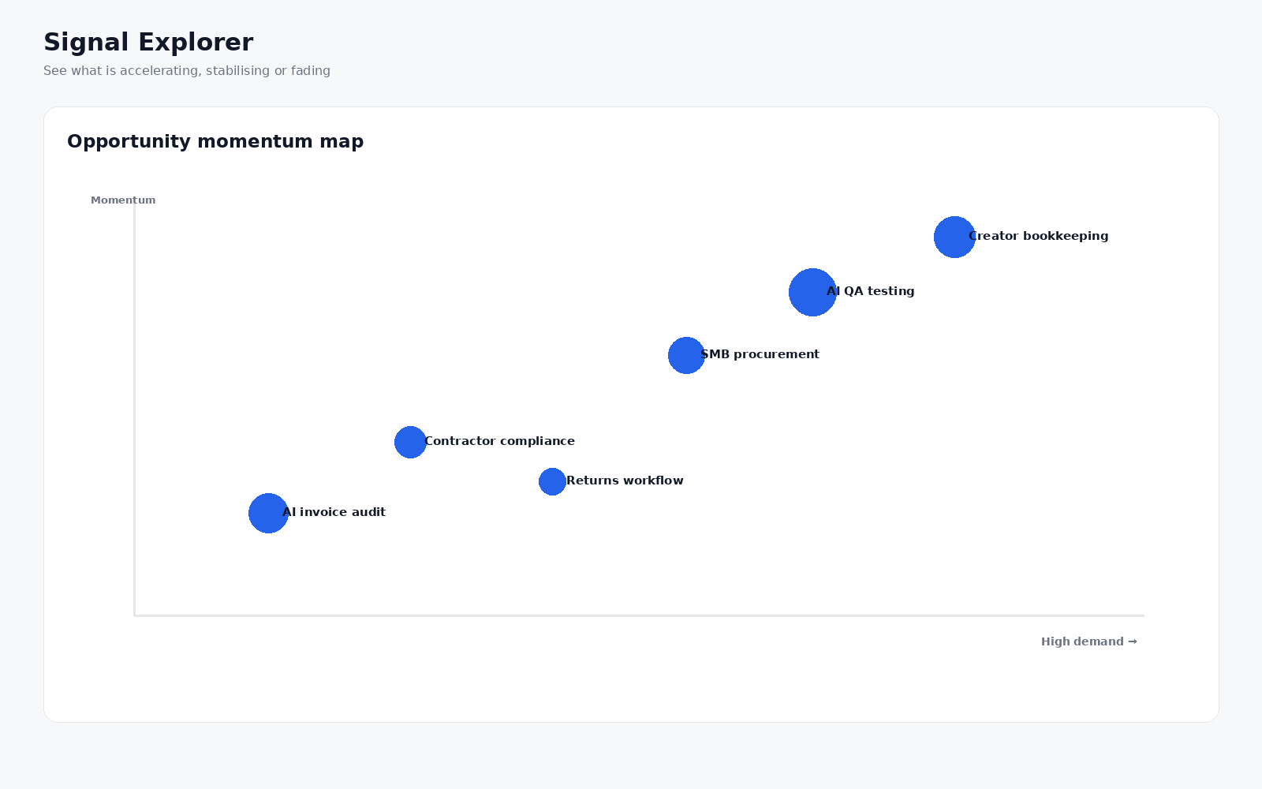
Visual exploration of momentum and emerging opportunities.

6. Recommended Visualizations
- 30/90/180-day demand line chart.
- Source diversity stacked bar.
- Intent mix chart.
- Demand-vs-competition matrix.
- Opportunity scatter plot.
- Category heatmap.
- Emerging → growing → crowded → declining lifecycle.

